BUSINESS INSIGHT REPORT
Power BI Dashboard Analysis
Dataset Name
GLOBAL SALES & FINANCIAL PERFORMANCE
Prepared By
PRAVEEN KUMAR B

INTRODUCTION

This report presents a comprehensive analysis of the Global Sales & Financial Performance dataset, visualized through an interactive Power BI dashboard. The purpose of this report is to translate the dashboard's key performance indicators and visualizations into actionable business insight, covering overall sales and profitability, product category performance, monthly sales trends, regional distribution, and employee contribution.

The analysis aims to identify strengths, uncover areas of concern, and support data-driven decision-making across inventory planning, marketing, regional expansion, workforce management, and customer targeting. Each section that follows examines a specific dimension of the business and concludes with observations drawn directly from the dashboard metrics.

DASHBOARD OVERVIEW

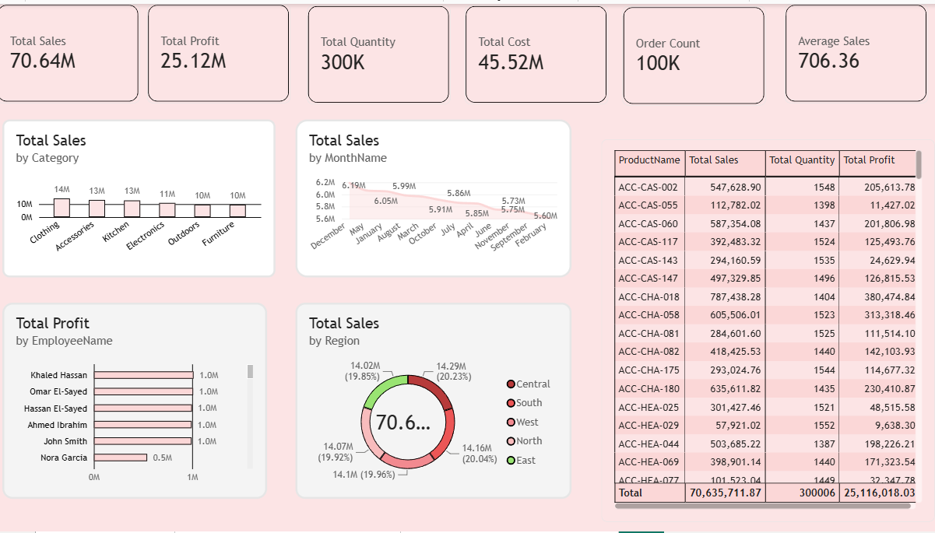
The dashboard consolidates the organization's sales and financial performance into a single view. The top row of KPI cards reports Total Sales (70.64M), Total Profit (25.12M), Total Quantity (300K units), Total Cost (45.52M), Order Count (100K), and Average Sales (706.36) per order. Below these cards, six visuals break the performance down by Category, MonthName, EmployeeName, and Region, alongside a detailed product-level table listing Total Sales, Total Quantity, and Total Profit for each product. Together, these visuals give both a high-level summary and a granular, product-by-product view of business performance.

3. KPI ANALYSIS
Total Sales  70.64M | Total Profit  25.12M | Total Quantity  300K
Total Cost  45.52M | Order Count  100K | Average Sales  706.36

The business generated Total Sales of 70.64M against a Total Cost of 45.52M, resulting in a Total Profit of 25.12M — an overall profit margin of approximately 35.5%. This is a healthy margin, indicating that pricing and cost control are generally well managed across the product range.
A total of 100K orders were processed, moving 300K units, which places the Average Sales value per order at 706.36. This relatively modest per-order value, combined with a high order count, suggests the business operates on a high-volume, moderate-ticket-size model rather than relying on a small number of large transactions.
Overall, the KPI summary points to a financially stable operation with strong profitability, but the average order value signals an opportunity to grow revenue through upselling or bundling rather than through order volume alone.
4. PRODUCT CATEGORY PERFORMANCE ANALYSIS
Category | Total Sales
Clothing | 14M
Accessories | 13M
Kitchen | 13M
Electronics | 11M
Outdoors | 10M
Furniture | 10M

Clothing leads all categories with 14M in total sales, closely followed by Accessories and Kitchen at 13M each. Electronics trails at 11M, while Outdoors and Furniture are the weakest performers, each contributing 10M. The spread between the top and bottom categories is relatively narrow (a 4M gap), indicating a fairly balanced product portfolio rather than dependence on a single dominant category.
Clothing, Accessories, and Kitchen together account for the largest share of revenue and should be prioritized for inventory availability and marketing investment, while Furniture and Outdoors may need promotional support or a review of pricing and assortment to close the performance gap.

5. MONTHLY SALES TREND ANALYSIS
Month | Total Sales
December | 6.19M
May | 5.99M
January | 6.05M
August | 5.91M
March | 5.85M
October | 5.86M
July | 5.75M
April | 5.73M
June | 5.60M

Monthly sales show a gradual downward trend across the year, starting at a peak of 6.19M in December and declining through the following months to a low of 5.60M in June. January (6.05M), May (5.99M), and October (5.86M) are the next strongest months, while June is the weakest point on the chart.
The overall pattern suggests seasonal softening moving from the winter months into mid-year, with December standing out as the strongest sales period likely tied to holiday or year-end purchasing. This trend supports timing major promotions and inventory build-up ahead of the December peak, and investigating targeted campaigns to lift sales during the June trough.
6.REGIONAL SALES ANALYSIS
Region | Total Sales | % of Total
North | 14.29M | 20.23%
East | 14.16M | 20.04%
West | 14.10M | 19.96%
South | 14.07M | 19.92%
Central | 14.02M | 19.85%

Sales are distributed almost evenly across all five regions, each contributing close to 20% of total revenue. North leads marginally at 14.29M (20.23%), followed by East (14.16M, 20.04%), West (14.10M, 19.96%), South (14.07M, 19.92%), and Central (14.02M, 19.85%).
This near-uniform distribution indicates a well-balanced geographic footprint with no single region dominating or lagging significantly behind the others. Because performance is so evenly spread, regional expansion decisions should be guided less by underperformance and more by identifying regions with the greatest untapped growth potential or lowest market penetration relative to population or demand.

7. EMPLOYEE PERFORMANCE ANALYSIS
Employee | Total Profit
Khaled Hassan | 1.0M
Omar El-Sayed | 1.0M
Hassan El-Sayed | 1.0M
Ahmed Ibrahim | 1.0M
John Smith | 1.0M
Nora Garcia | 0.5M

Five of the six employees Khaled Hassan, Omar El-Sayed, Hassan El-Sayed, Ahmed Ibrahim, and John Smith each generated approximately 1.0M in total profit, showing a consistent and strong level of performance across most of the team. Nora Garcia, however, generated only 0.5M, roughly half the contribution of the other employees.
This gap identifies Nora Garcia as a clear outlier who may benefit from additional coaching, a review of assigned accounts or territories, or further investigation into whether the shortfall stems from tenure, workload, or external factors. The consistency among the remaining five employees suggests that current sales practices and training are effective and could be used as the basis for onboarding or mentoring support.

8. BUSINESS RECOMMENDATIONS
Inventory Planning
- Increase stock levels for Clothing, Accessories, and Kitchen ahead of peak months, particularly December, to avoid stockouts during high-demand periods.
- Reassess inventory commitments for Furniture and Outdoors, as their lower sales volume may be tying up capital that could be redirected to stronger categories.
Marketing Strategy
- Launch targeted promotional campaigns during the June sales trough to smooth out the seasonal dip observed in the monthly trend.
- Build on the December peak with early holiday marketing pushes and bundle offers to further capitalize on the season's natural demand.
Regional Expansion
- Since sales are evenly distributed across all five regions, prioritize expansion based on market size and untapped demand rather than correcting regional imbalance.
- Pilot new customer-acquisition initiatives in one region at a time to measure incremental impact before scaling company-wide.
Employee Performance
- Provide targeted coaching or mentorship for Nora Garcia to help close the profit gap relative to the rest of the team.
- Document and share the practices of top-performing employees (Khaled Hassan, Omar El-Sayed, Hassan El-Sayed, Ahmed Ibrahim, John Smith) as a benchmark for onboarding and training.
Product Portfolio
- Expand the assortment within top-performing categories (Clothing, Accessories, Kitchen) where demand is proven.
- Evaluate whether underperforming Furniture and Outdoors products should be repositioned, discounted, or phased out in favor of higher-margin items.
Customer Targeting
- Use the relatively low Average Sales value per order (706.36) as a starting point to design upsell and cross-sell offers that increase basket size.
- Segment customers by purchasing category to enable more personalized marketing, particularly for high-performing categories with room to grow.

